**Name : Rohan Sunil Kadam. Assignment : 2 ( Extended task 1 )**

**Subject : Web Scrapping on Aws Clouds and storing data on mongodb showing output.**

**Date : 28-march-2023**

**Details about task :**

Web scraping (or data scraping) is a technique used to collect content and data from the internet. This data is usually saved in a local file so that it can be manipulated and analyzed as needed. In this case we

store data in mongodb database in json format. For Web Scraping using beautifulSoup (Beautiful Soup is a

Python package for parsing HTML and XML documents.) Scraping e-commerce site Flipkart.

**Github Code :** [**https://github.com/KRohancoder/internship-work.git**](https://github.com/KRohancoder/internship-work.git)

**Requirement :**

1) Jupyternote book (Python IDE)

2) Mongodb compass (for store data)

3) AWS Cloud (Creating virtual machine)

Task Working Framework :

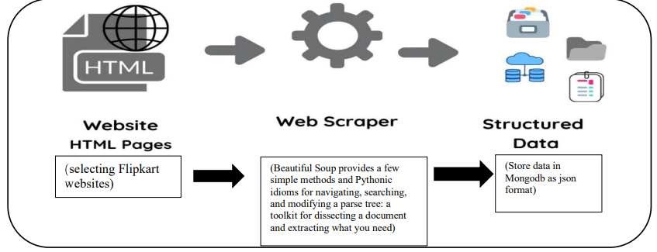

Sites : <https://www.flipkart.com/search?p%5B%5D=facets.brand%255B%255D%3DSamsung&sid=tyy%2F4io&sort=recency_desc&wid=1.productCard.PMU_V2_1&page=1>

We can put data in mongodb using following code (refer assigmnet 1 code ):

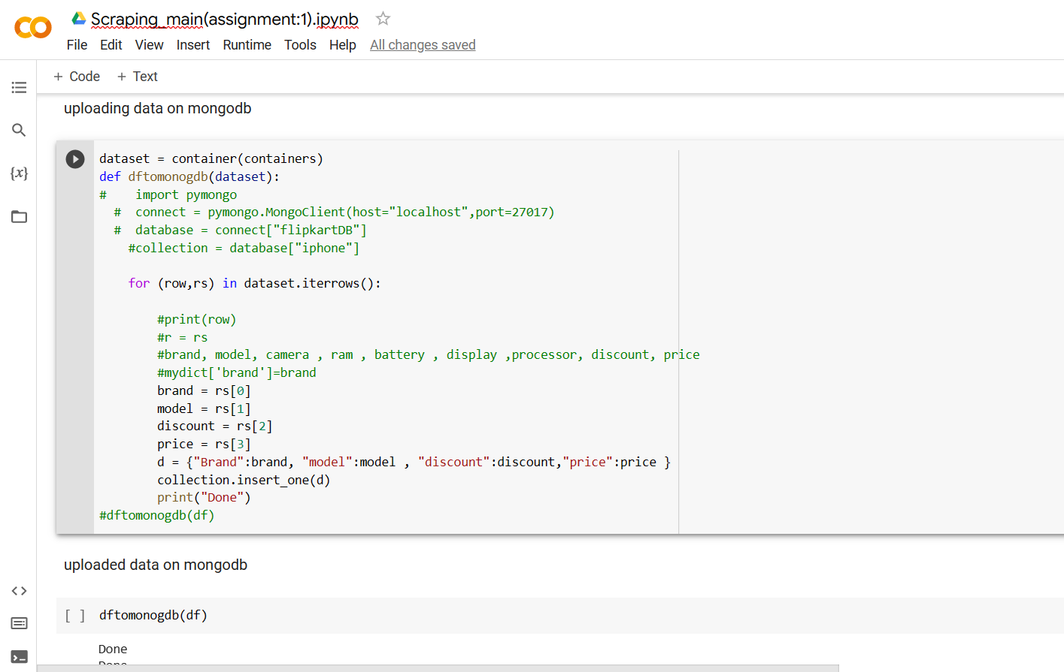

**Outputs :** ( Scraping Samsung mobile data in more details as shown in below. )

